Antarmuka & Peripheral

Tugas Pertemuan 2



Nama : Irawan

NIM : 0901128621057

Kelas : SK7B

Dosen Pengampuh : Rendyansyah S.Kom., M.T.

Jurusan Sistem Komputer

Fakultas Ilmu Komputer

Universitas Sriwijaya

2018

Tugas :

Antarmuka:

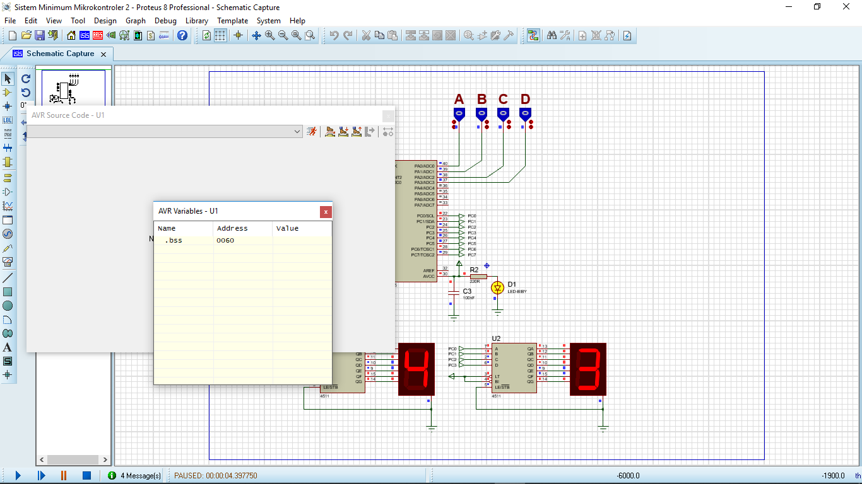

Code CVAVR:

/*******************************************************

This program was created by the

CodeWizardAVR V3.12 Advanced

Automatic Program Generator

© Copyright 1998-2014 Pavel Haiduc, HP InfoTech s.r.l.

http://www.hpinfotech.com

Project :

Version :

Date : 11/09/2019

Author :

Company :

Comments:

Chip type : ATmega8535

Program type : Application

AVR Core Clock frequency: 8,000000 MHz

Memory model : Small

External RAM size : 0

Data Stack size : 128

*******************************************************/

#include <mega8535.h>

#include <delay.h>

// Declare your global variables here

//unsigned char cnt[10] = {0xc0,0xf9,0xa4,0xb0,0x99,0x92,0x82,0xf8,0x80,0x90};

void main(void)

{

// Declare your local variables here

int right;

int left;

//int i;

// Input/Output Ports initialization

// Port A initialization

// Function: Bit7=In Bit6=In Bit5=In Bit4=In Bit3=In Bit2=In Bit1=In Bit0=In

DDRA=(0<<DDA7) | (0<<DDA6) | (0<<DDA5) | (0<<DDA4) | (0<<DDA3) | (0<<DDA2) | (0<<DDA1) | (0<<DDA0);

// State: Bit7=T Bit6=T Bit5=T Bit4=T Bit3=T Bit2=T Bit1=T Bit0=T

PORTA=(0<<PORTA7) | (0<<PORTA6) | (0<<PORTA5) | (0<<PORTA4) | (0<<PORTA3) | (0<<PORTA2) | (0<<PORTA1) | (0<<PORTA0);

// Port B initialization

// Function: Bit7=In Bit6=In Bit5=In Bit4=In Bit3=In Bit2=In Bit1=In Bit0=In

DDRB=(0<<DDB7) | (0<<DDB6) | (0<<DDB5) | (0<<DDB4) | (0<<DDB3) | (0<<DDB2) | (0<<DDB1) | (0<<DDB0);

// State: Bit7=T Bit6=T Bit5=T Bit4=T Bit3=T Bit2=T Bit1=T Bit0=T

PORTB=(0<<PORTB7) | (0<<PORTB6) | (0<<PORTB5) | (0<<PORTB4) | (0<<PORTB3) | (0<<PORTB2) | (0<<PORTB1) | (0<<PORTB0);

// Port C initialization

// Function: Bit7=Out Bit6=Out Bit5=Out Bit4=Out Bit3=Out Bit2=Out Bit1=Out Bit0=Out

DDRC=(1<<DDC7) | (1<<DDC6) | (1<<DDC5) | (1<<DDC4) | (1<<DDC3) | (1<<DDC2) | (1<<DDC1) | (1<<DDC0);

// State: Bit7=0 Bit6=0 Bit5=0 Bit4=0 Bit3=0 Bit2=0 Bit1=0 Bit0=0

PORTC=(0<<PORTC7) | (0<<PORTC6) | (0<<PORTC5) | (0<<PORTC4) | (0<<PORTC3) | (0<<PORTC2) | (0<<PORTC1) | (0<<PORTC0);

// Port D initialization

// Function: Bit7=In Bit6=In Bit5=In Bit4=In Bit3=In Bit2=In Bit1=In Bit0=In

DDRD=(0<<DDD7) | (0<<DDD6) | (0<<DDD5) | (0<<DDD4) | (0<<DDD3) | (0<<DDD2) | (0<<DDD1) | (0<<DDD0);

// State: Bit7=T Bit6=T Bit5=T Bit4=T Bit3=T Bit2=T Bit1=T Bit0=T

PORTD=(0<<PORTD7) | (0<<PORTD6) | (0<<PORTD5) | (0<<PORTD4) | (0<<PORTD3) | (0<<PORTD2) | (0<<PORTD1) | (0<<PORTD0);

// Timer/Counter 0 initialization

// Clock source: System Clock

// Clock value: Timer 0 Stopped

// Mode: Normal top=0xFF

// OC0 output: Disconnected

TCCR0=(0<<WGM00) | (0<<COM01) | (0<<COM00) | (0<<WGM01) | (0<<CS02) | (0<<CS01) | (0<<CS00);

TCNT0=0x00;

OCR0=0x00;

// Timer/Counter 1 initialization

// Clock source: System Clock

// Clock value: Timer1 Stopped

// Mode: Normal top=0xFFFF

// OC1A output: Disconnected

// OC1B output: Disconnected

// Noise Canceler: Off

// Input Capture on Falling Edge

// Timer1 Overflow Interrupt: Off

// Input Capture Interrupt: Off

// Compare A Match Interrupt: Off

// Compare B Match Interrupt: Off

TCCR1A=(0<<COM1A1) | (0<<COM1A0) | (0<<COM1B1) | (0<<COM1B0) | (0<<WGM11) | (0<<WGM10);

TCCR1B=(0<<ICNC1) | (0<<ICES1) | (0<<WGM13) | (0<<WGM12) | (0<<CS12) | (0<<CS11) | (0<<CS10);

TCNT1H=0x00;

TCNT1L=0x00;

ICR1H=0x00;

ICR1L=0x00;

OCR1AH=0x00;

OCR1AL=0x00;

OCR1BH=0x00;

OCR1BL=0x00;

// Timer/Counter 2 initialization

// Clock source: System Clock

// Clock value: Timer2 Stopped

// Mode: Normal top=0xFF

// OC2 output: Disconnected

ASSR=0<<AS2;

TCCR2=(0<<WGM20) | (0<<COM21) | (0<<COM20) | (0<<WGM21) | (0<<CS22) | (0<<CS21) | (0<<CS20);

TCNT2=0x00;

OCR2=0x00;

// Timer(s)/Counter(s) Interrupt(s) initialization

TIMSK=(0<<OCIE2) | (0<<TOIE2) | (0<<TICIE1) | (0<<OCIE1A) | (0<<OCIE1B) | (0<<TOIE1) | (0<<OCIE0) | (0<<TOIE0);

// External Interrupt(s) initialization

// INT0: Off

// INT1: Off

// INT2: Off

MCUCR=(0<<ISC11) | (0<<ISC10) | (0<<ISC01) | (0<<ISC00);

MCUCSR=(0<<ISC2);

// USART initialization

// USART disabled

UCSRB=(0<<RXCIE) | (0<<TXCIE) | (0<<UDRIE) | (0<<RXEN) | (0<<TXEN) | (0<<UCSZ2) | (0<<RXB8) | (0<<TXB8);

// Analog Comparator initialization

// Analog Comparator: Off

// The Analog Comparator's positive input is

// connected to the AIN0 pin

// The Analog Comparator's negative input is

// connected to the AIN1 pin

ACSR=(1<<ACD) | (0<<ACBG) | (0<<ACO) | (0<<ACI) | (0<<ACIE) | (0<<ACIC) | (0<<ACIS1) | (0<<ACIS0);

SFIOR=(0<<ACME);

// ADC initialization

// ADC disabled

ADCSRA=(0<<ADEN) | (0<<ADSC) | (0<<ADATE) | (0<<ADIF) | (0<<ADIE) | (0<<ADPS2) | (0<<ADPS1) | (0<<ADPS0);

// SPI initialization

// SPI disabled

SPCR=(0<<SPIE) | (0<<SPE) | (0<<DORD) | (0<<MSTR) | (0<<CPOL) | (0<<CPHA) | (0<<SPR1) | (0<<SPR0);

// TWI initialization

// TWI disabled

TWCR=(0<<TWEA) | (0<<TWSTA) | (0<<TWSTO) | (0<<TWEN) | (0<<TWIE);

while (1)

{

for(left=0;left<=9;left++)

{

for(right=0;right<=9;right++)

{

PORTC=right+(left*16);

delay_ms(100);

}

}

}

}